LED UV Exposure Unit

This custom-built UV exposure unit is primarily designed for exposing Photopolymer printing plates such as used by the photogravure printing process. This process requires an efficient and evenly distributed light source over the entire plate area.
The unit is also suitable for other similar applications where UV light is required for exposing photo sensitive substrates, such as cyanotypes etc.

The UV Exposure Unit was built to provide a UV spectral wavelength output of 365 nm, being ideal for photopolymer printing plates.

The unit comes in 2 sizes – A2 and A4.

The A2 unit has LED strip lighting total 900 LED diodes arranged over a 600 x 800mm area, suitable for up to A2 size plates with space to spare.

The A4 unit has LED strip lighting total 450 LED diodes arranged over a 300 x 275mm area, suitable for up to A4 size plates with space to spare.

A dimmer control on the front panel is provided should the UV intensity need to be reduced.

The A2 unit measures approx. W824mm x D623mm x H290mm, in a varnished plywood enclosure.
The A4 unit measures approx. W520mm x D450mm x H300mm, in a varnished plywood enclosure.

All electronics are housed in a separate removable module to facilitate access if required.

A2 unit - Power: 240AC mains, 150W
A4 unit - Power: 240AC mains, 60W

Exposure time is either controlled by a digital timer or timed manually. The unit is fitted with a safety cut-off switch to prevent unwanted UV exposure when accessing the exposure area. The light will cut off if the lid is opened while the exposure unit is running, making the unit safe for schools and workshops.

The unit is designed and hand built by Tom Glattauer in Melbourne, Australia.

Price:
A2 Unit - $2,500
A4 Unit - $1,700

Packing a shipping extra. Australia Only.

Further Information – Silvi Glattauer – 0417 377 962 – silvi@silvi.com.au

View video of exposure unit - https://youtu.be/eUjFsPWWYM8

A2 LED UV Light Box - W824mm x D623mm x H290mm
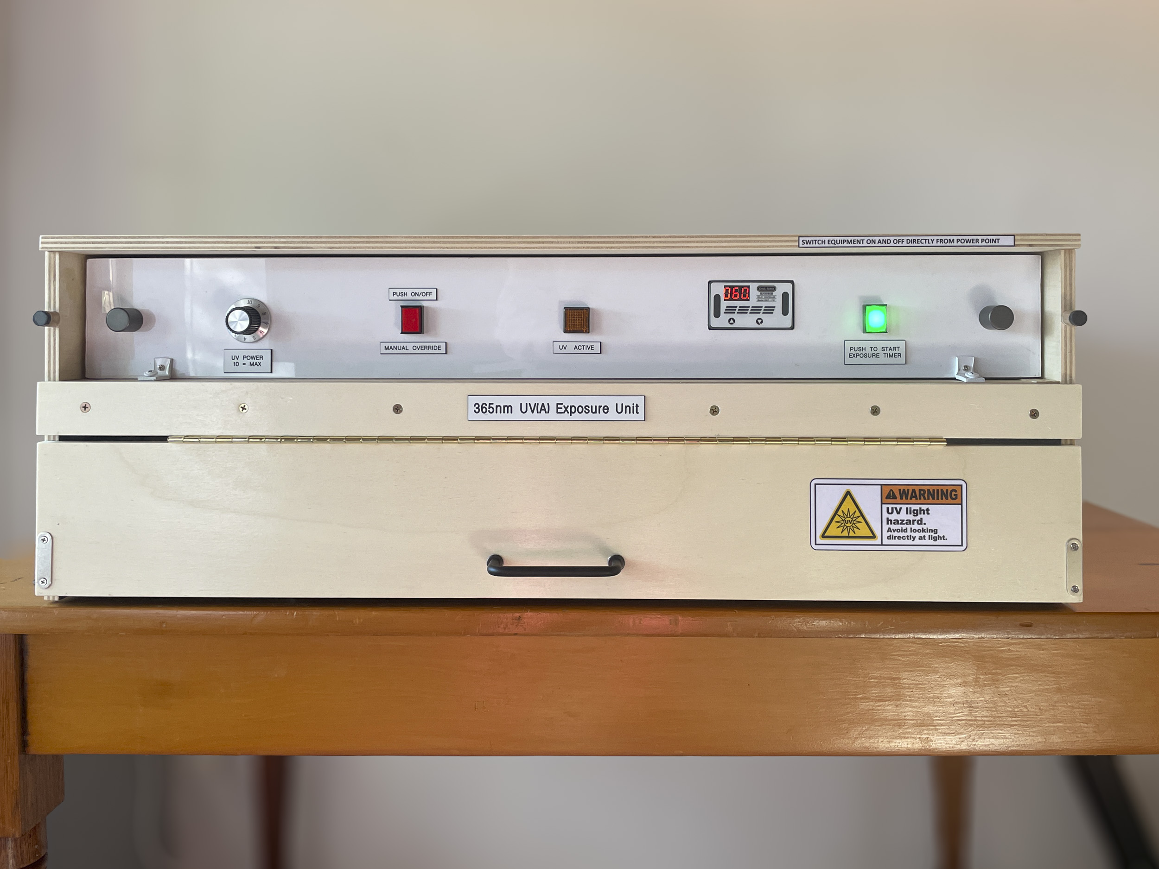
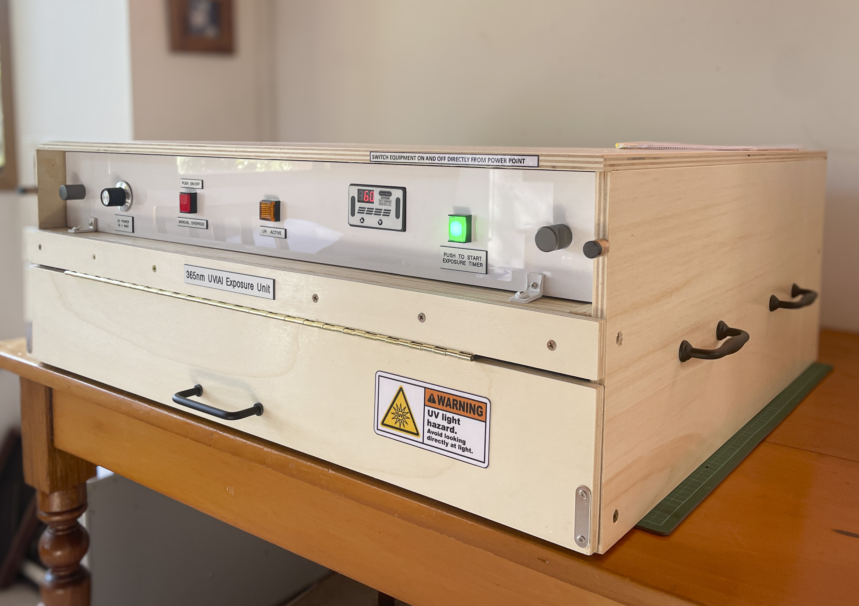

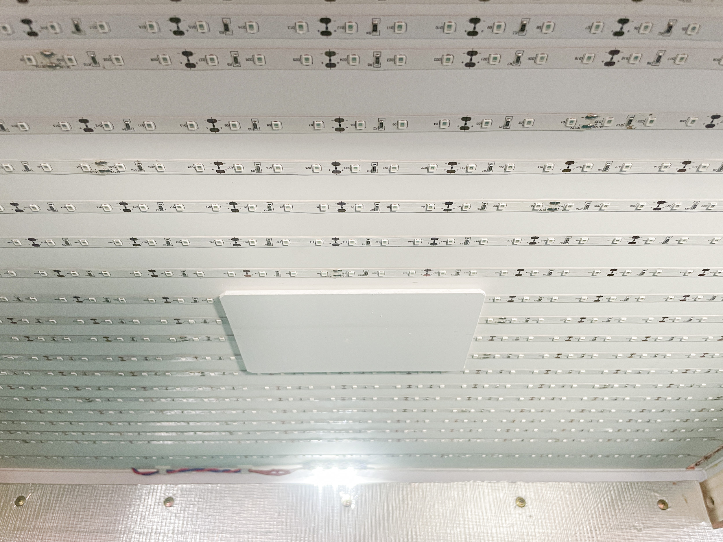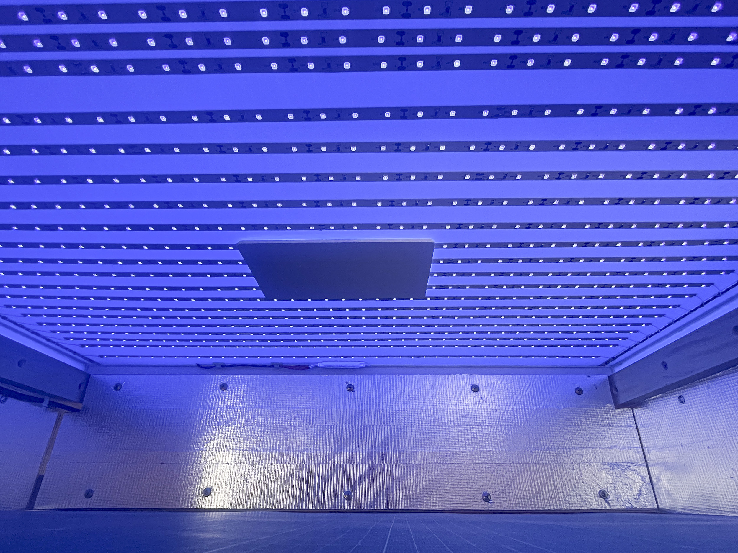

A4 LED UV Light Box - W520mm x D450mm x H300mm

